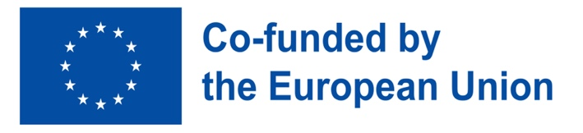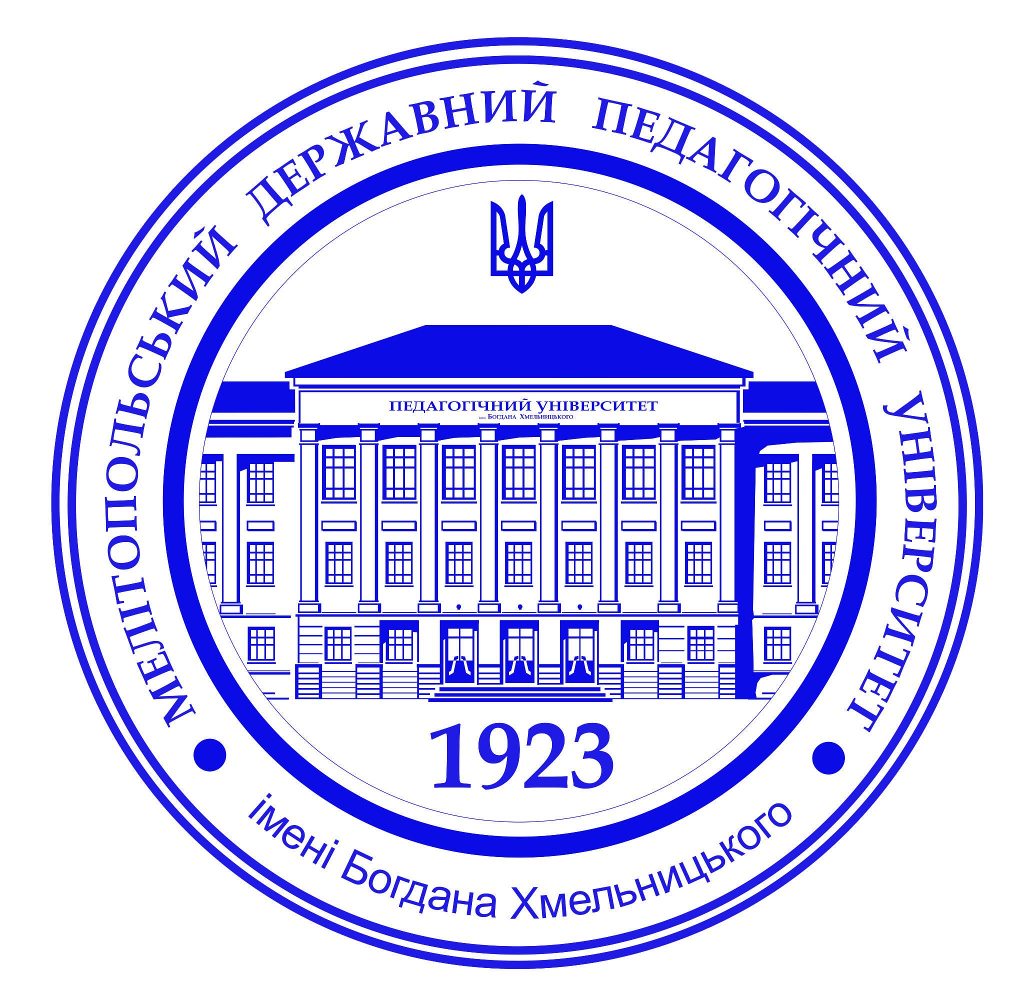



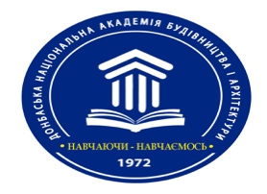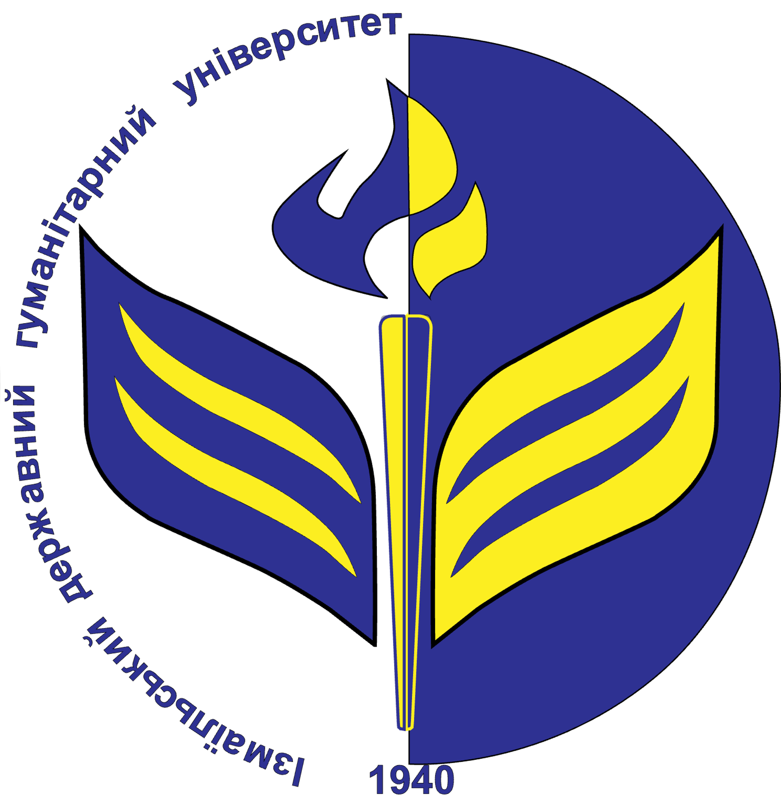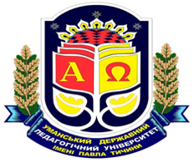

 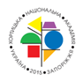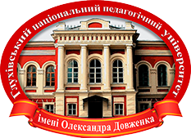

Ministry of Education and Science of Ukraine

Bogdan Khmelnitsky Melitopol State Pedagogical University

Donbas National Academy of Civil Engineering and Architecture

Izmail State University of Humanities

Mukachevo State University

Odesa National University of Technology

Pavlo Tychyna Uman State Pedagogical University (Department of Foreign Languges)

[Nizhyn Mykola Gogol State University](https://en.ndu.edu.ua/)

[Khortytsk National Academy](https://khnnra.edu.ua/). Communal institution of higher education

Oleksandr Dovzhenko Hlukhiv National Pedagogical University

**DEAR COLLEAGUES!**

We invite you to participate in

the 2nd NATIONAL SCIENTIFIC-PRACTICAL INTERNET-CONFERENCE

**“STRENGTHENING COMMON EUROPEAN VALUES THROUGH EDUCATION”,**

held within implementation of **the EU-funded Programme Erasmus+ Jean Monnet Module “Strengthening the EU common values through the policy of multilingualism in the education and training of future teachers” 101083321 - SEUCV ETT - ERASMUS-JMO-2022-HEI-TCH-RSCH**

***Zaporizhzhia – Melitopol, 25 October 2024***

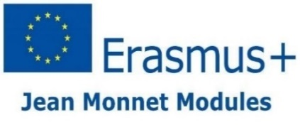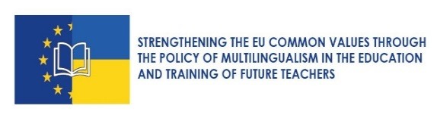

The aim of the conference is to discuss the issues of Ukraine’s entry into the European Union, the European educational space and promotion of the EU common values. In the global scale the conference will establish new scientific networks of educators and researchers from different universities of our country, who are ready to share the results of their studies and experience on reforming the system of education in Ukraine.

The programme of the conference includes plenary discussion and section meetings.

**Conference sections:**

1. The EU common values dissemination for the development of a new pro-European primary and secondary education in Ukraine.
2. European dimensions of sustainable development of Ukrainian higher education.
3. European studies for inclusive education in the social and pedagogical dimensions.

The detailed programme with a link will be sent later.

Working languages of the conference: Ukrainian, English.

The participation in this conference is ***free of charge.***

To participate in the conference **by 18 October 2024** fill in the application form (in English and Ukrainian) and attach theses of the report (in English or Ukrainian) via Google form: <http://surl.li/aeqtby>

Address for e-mailing: [mav2429@gmail.com](mailto:mav2429@gmail.com)

Telephone for inquiries:

+380971979424 Olga Goncharova

+380976677899 Alina Maslova

**GUIDELINES FOR AUTHORS**

The theses of the report are submitted in the Microsoft Word editor (Times New Roman, size – 14, line spacing – 1.5, paragraph indent – 1 cm, all edges – 2 cm) in .doc format without hyphenation in words. The last name and initials are typed in the right upper corner. The title of the theses is put in capital letters, in bold, with centre alignment symmetrically to the text. The main text is put one line after the title. The sources cited in the References should be given in the alphabetical order; references in the text should be made in square brackets, indicating the source number and page: [1, p. 45]. Theses should be 2-3 pages long. References should be completed according to the State Standard of Ukraine 8302:2015 (ДСТУ 8302:2015).

**Sample**

A.V. Maslova

Bogdan Khmelnitsky Melitopol

State Pedagogical University

**TITLE OF THE THESES**

Text …………………………………………………………………………..

REFERENCES

1. Tymoshenko Z. I. Bolonskyi protses v dii: slovnyk-dovidnyk. K.: Yevrop. un-t, 2007. 219 s.

*“Funded by the European Union. Views and opinions expressed are however those of the author(s) only and do not necessarily reflect those of the European Union or the European Education and Culture Executive Agency (EACEA). Neither the European Union nor the granting authority can be held responsible for them"*